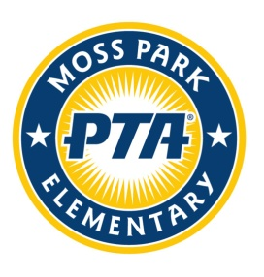[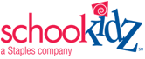](http://www.schoolkidz.com/)

**SCHOOL SUPPLY KITS**

Once again, Moss Park PTA will be using the convenient online services of SchoolKidz by Staples for an easy and affordable back-to-school supply kit program.

Last year our PTA board put the supply kit pricing to the test. We all shopped and saved our receipts to compare the value of the supply kits for every grade level. Only 1 board member came in about $1 less. Everyone else spent about $3 - $10 more than the kit price! When we factored in time, tolls, and gas – every board member agreed that the kits were a better value! Plus since PTA is selling the kits, they are **tax free**! Kits range from $70 - $85 dollars depending on the grade level supply requirements.

Teachers love the kits too! SchoolKidz, Inc. offers brand name items such as Crayola® & Elmer’s® as well as Staples brands. Each item is exactly what is on your child’s supply list including specific items for boys or girls. There are also options for back packs, water bottles and lunch bags.

All kits will be delivered to the school so you can either pick them up at Meet the Teacher in August, or if you can’t attend that event then PTA will deliver the kit to your child’s classroom.

PTA hopes this supply kit option makes it easier for some of our families!

**Moss Park Elementary School**

[**www.Shopttkits.com**](http://www.Shopttkits.com) **Account #62489**

2014 Pre-packaged Supply Kits **Online Orders Only**

**Orders must be placed online by June 16th**

**(**Sorry - No **late orders accepted)**

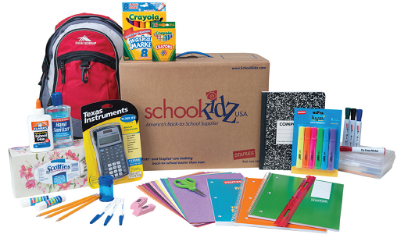

If you have any questions, email VPCommunications@PTAMossPark.com

Remember to order

the kit for the grade

that your child will be in

**NEXT YEAR**!